DOCKER task- 01
- Setup a virtual machine using Ubuntu image.
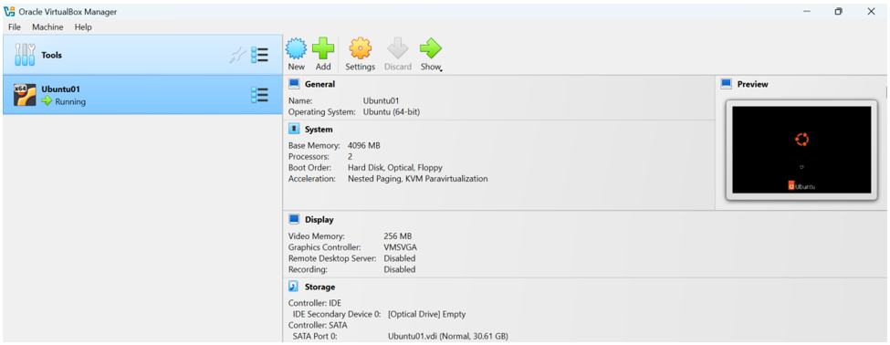
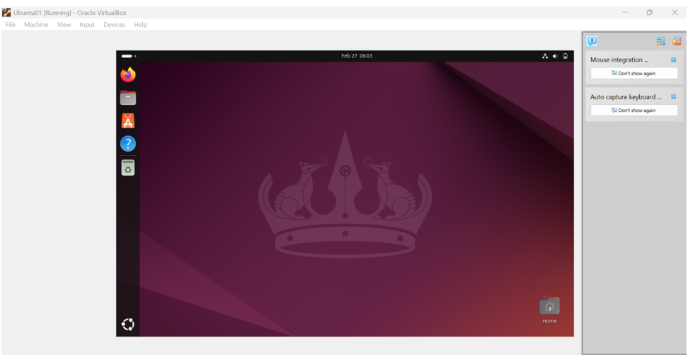
- Install docker on ec2.

Step 1: Launch an EC2 Instance

Go to **Amazon Web Services Console → EC2**
- Configure:
* AMI: **Amazon Linux 2023 AMI 2023.10.20260216.1 x86_64 HVM kernel-6.1**
* Instance type: `c7i-flex.large` (Free tier eligible)
* Key pair: Create or select existing
* Security Group:
* ✔ SSH (22) — Your IP
* ✔ HTTP (80) — Anywhere (if running web apps)
- Launch instance.
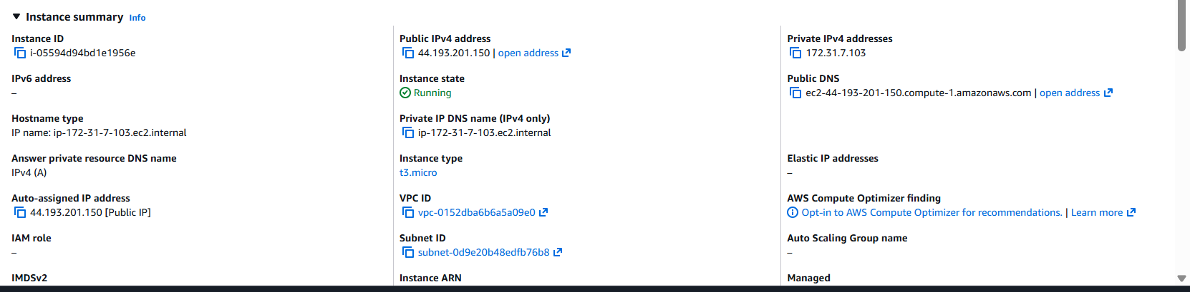
Step 2: Connect to EC2 via SSH
From your local terminal:
```bash
ssh -i your-key.pem ec2-user@your-ec2-public-ip
```

Step 3: Install Docker on Linux EC2
Update system :
```bash
sudo yum update
sudo yum upgrade -y
```
Install Docker :
```bash
sudo yum install docker -y
```
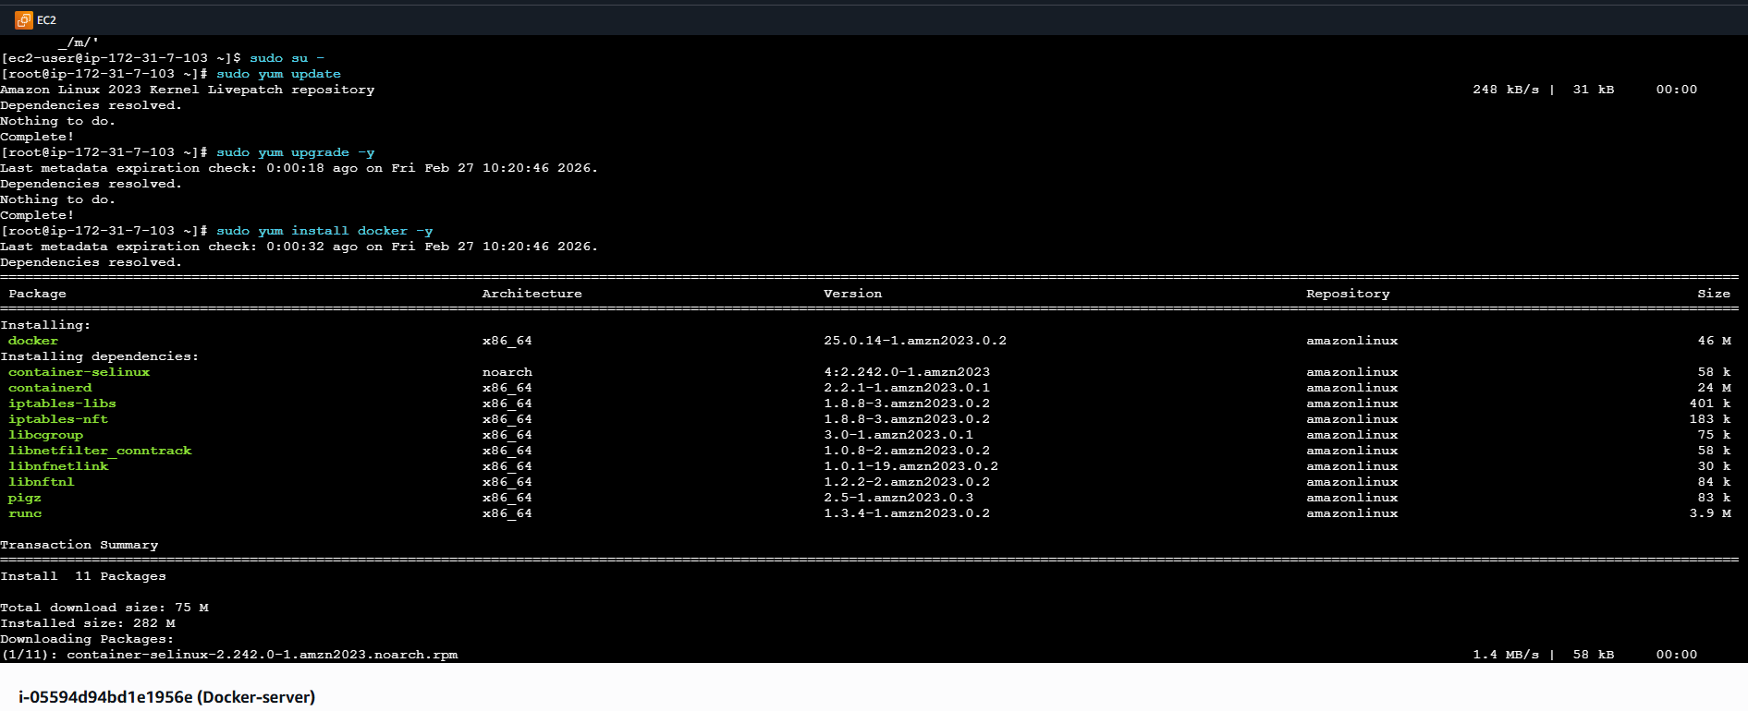
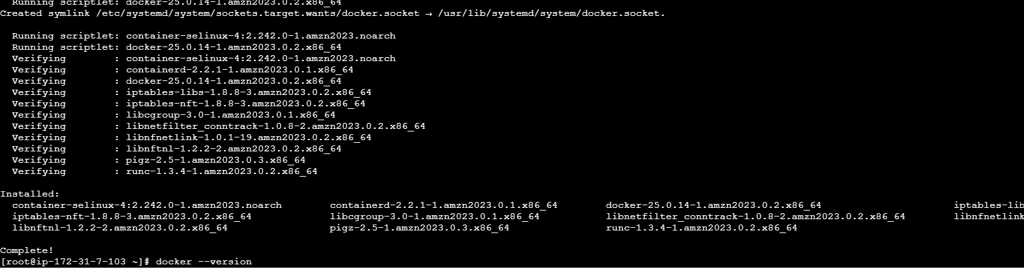

Step 4: Verify Docker Installation
Check version:
docker --version
Check service status:
sudo systemctl start docker
sudo systemctl status docker
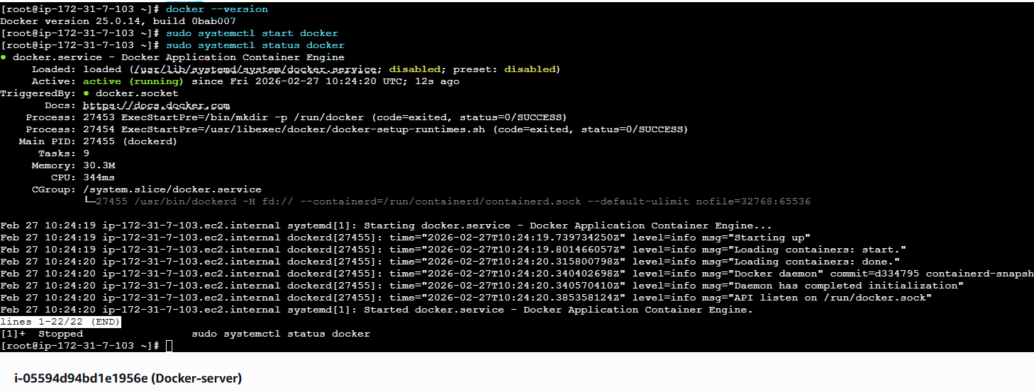
successful → Docker is installed .
- Pull 5 docker images. (nginx , apache , tomcat , ubuntu , jenkins , sonarqube )

First, make sure Docker is running:
sudo systemctl status docker
If needed:
sudo systemctl start docker
Pull Required Docker Images

Run the following commands:

1 Pull Nginx :
docker pull nginx

2 Pull Apache (httpd) :
docker pull httpd

3 Pull Tomcat :
docker pull tomcat

4 Pull Ubuntu :
docker pull ubuntu

5 Pull Jenkins :
docker pull jenkins/jenkins:lts

6 Pull SonarQube :
docker pull sonarqube
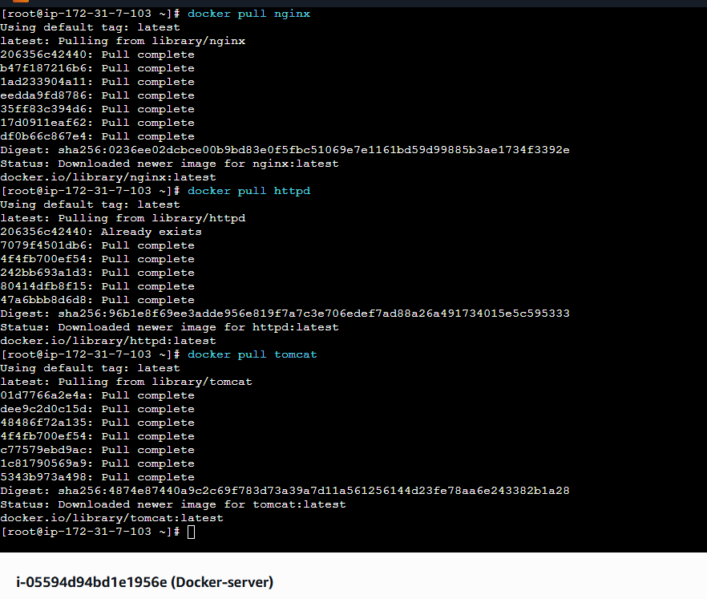
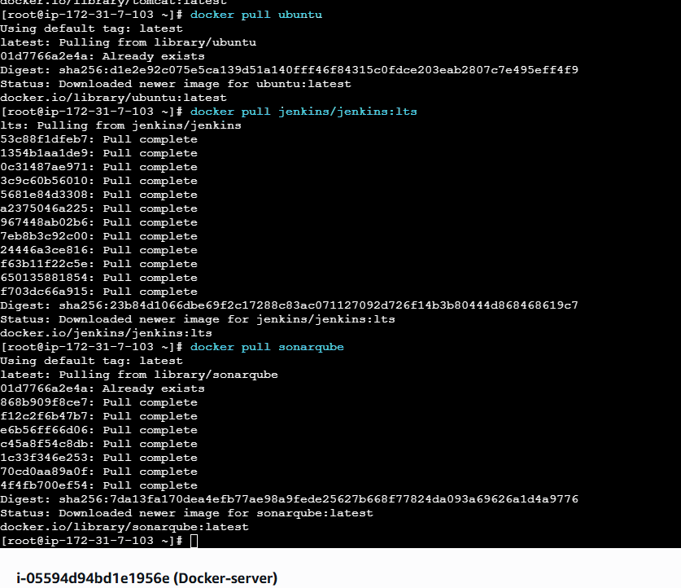
Verify Downloaded Images

After pulling, check:
docker images
You should see something like:
REPOSITORY TAG IMAGE ID SIZE
nginx latest xxxxxxxx xxxMB
httpd latest xxxxxxxx xxxMB
tomcat latest xxxxxxxx xxxMB
ubuntu latest xxxxxxxx xxxMB
jenkins/jenkins lts xxxxxxxx xxxMB
sonarqube latest xxxxxxxx xxxMB

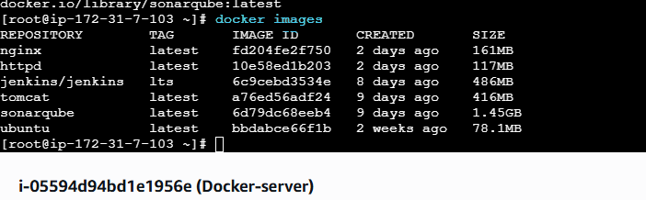
- Run nginx container and expose on port 81.

Step 1: Run Nginx on Port 81
Run this command:
docker run -d -p 81:80 --name my-nginx nginx
What this means:
* `-d` → Run in background
* `-p 81:80` → Map:
* EC2 Port **81** → Container Port **80**
* `--name my-nginx` → Container name
* `nginx` → Image
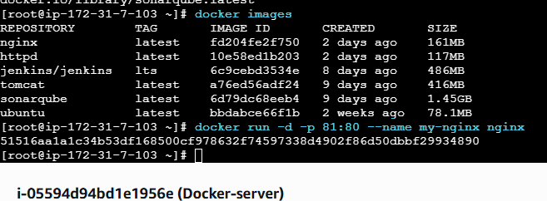
Step 2: Verify Container is Running :
docker ps
You should see something like:

CONTAINER ID IMAGE PORTS
xxxxxxx nginx 0.0.0.0:81->80/tcp
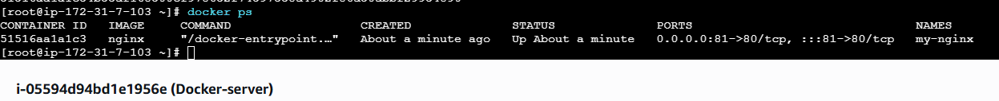
Step 3: Open Port 81 in EC2 Security Group (IMPORTANT)
Go to:
- EC2 → Security Groups → Inbound Rules**
Add rule:
| Type | Port | Source |
| ---------- | ---- | -------------------- |
| Custom TCP | 81 | Anywhere (0.0.0.0/0) |
Save.
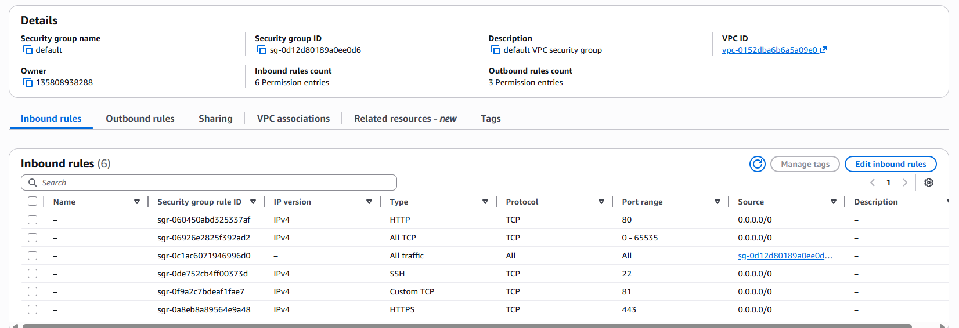
Step 4: Access in Browser
Open:
http://your-ec2-public-ip:81
You should see the Nginx welcome page
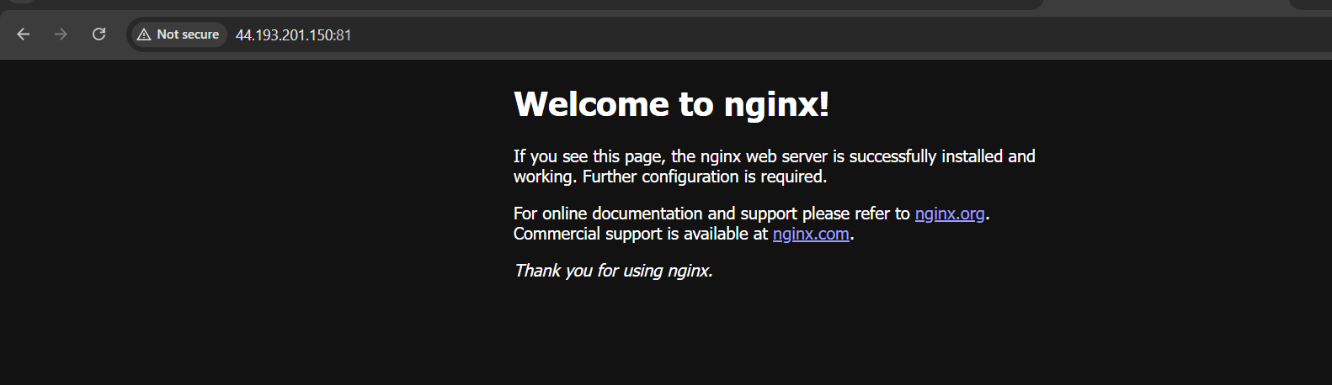
If It Doesn't Work

Check:
1. Is container running?
docker ps
- Check logs:
docker logs my-nginx
- Check EC2 firewall:
sudo systemctl status firewalld
Stop / Remove Container (Optional)
Stop:
docker stop my-nginx
Remove:
docker rm my-nginx

- Delete the apache tomcat image from local.

To delete the image the command is
docker rmi ‘image-name’
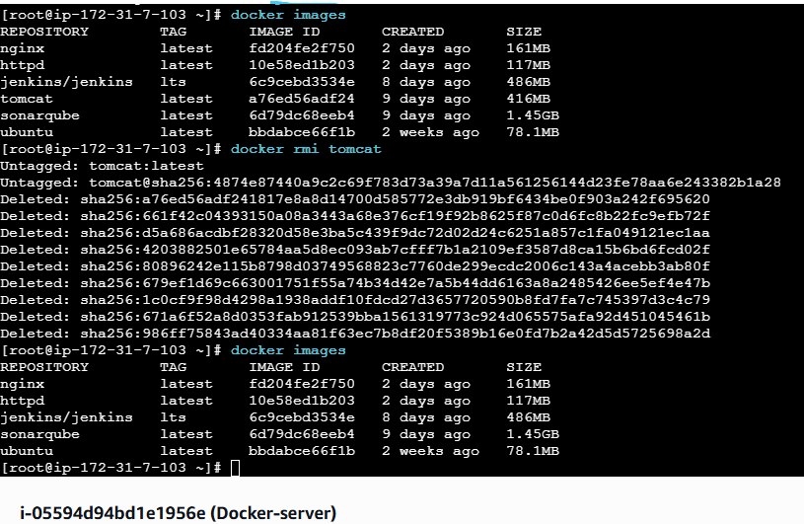

- Inspect the jenkins image,sonarqube image.

The command to inspect images is :
docker inspect (image name with tag ) or (image id)
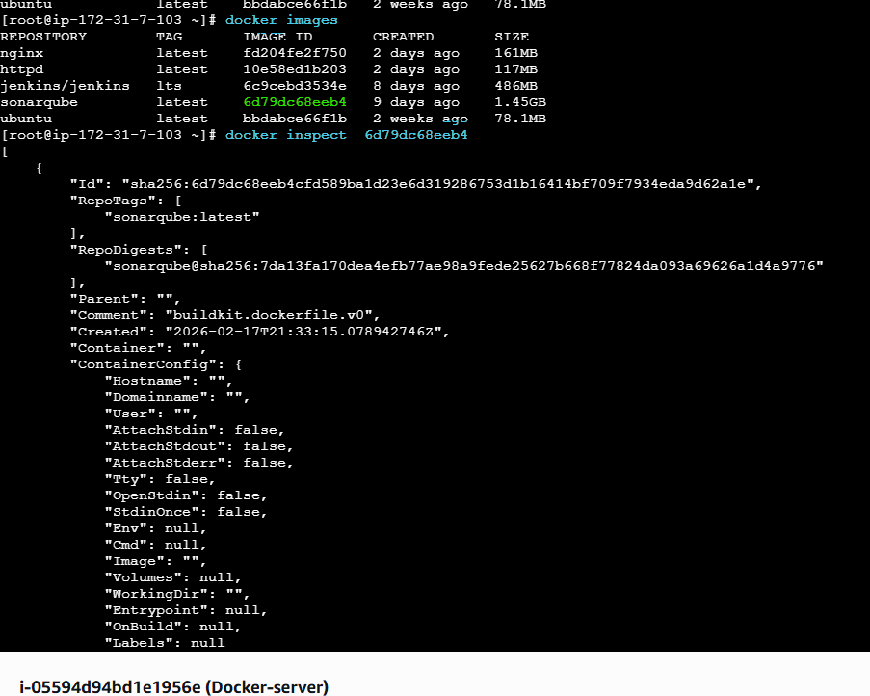
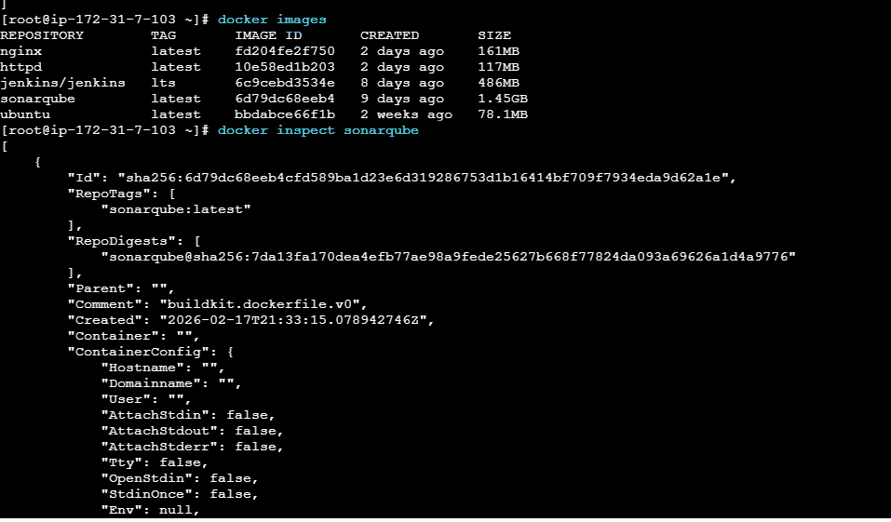

- Run jenkins contianer and run one sample job.

Step 1: Run Jenkins Container
Jenkins runs on port **8080** by default.
docker run -d -p 8080:8080 -p 50000:50000 --name jenkins jenkins/jenkins:lts
Explanation:
* `8080` → Jenkins Web UI
* `50000` → Agent communication port
* `--name jenkins` → Container name
* `jenkins/jenkins:lts` → Official LTS image

Step 2: Verify Container
docker ps
You should see:
0.0.0.0:8080->8080/tcp
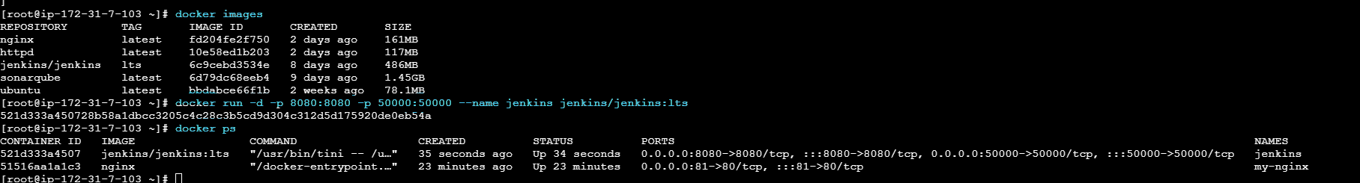
Step 3: Open Port 8080 in EC2 Security Group
Go to:
**EC2 → Security Groups → Inbound Rules**
Add:
| Type | Port | Source |
| ---------- | ---- | --------- |
| Custom TCP | 8080 | 0.0.0.0/0 |
Save.
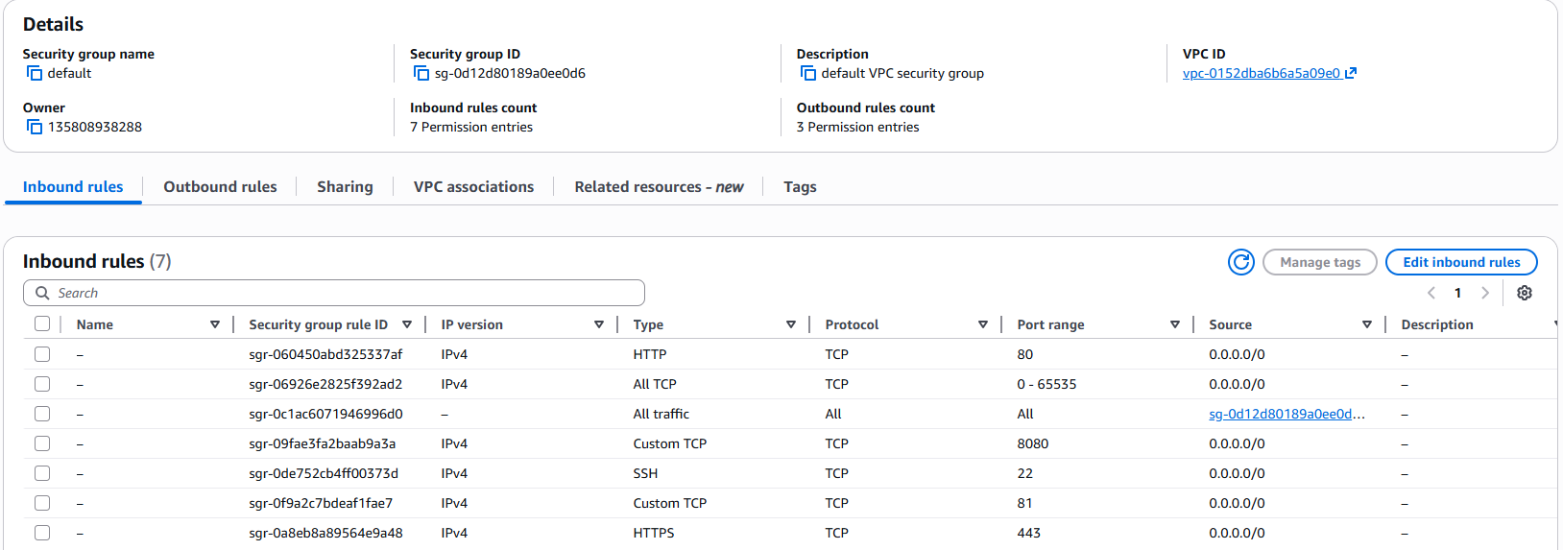
Step 4: Access Jenkins
Open in browser:
http://your-ec2-public-ip:8080
You’ll see Jenkins setup screen.
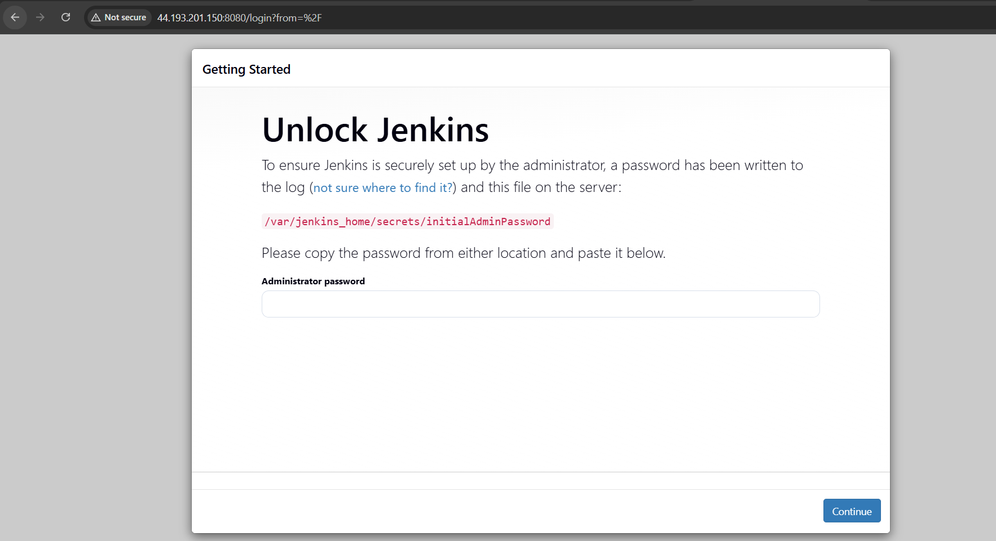
Step 5: Get Initial Admin Password
Run:
docker exec jenkins cat /var/jenkins_home/secrets/initialAdminPassword
Copy the password → Paste in browser → Continue.
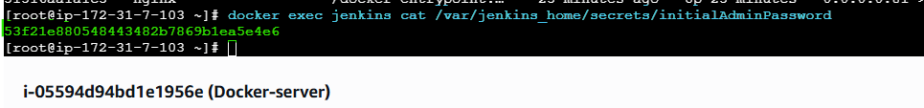
Step 6: Install Plugins
Choose:
Install Suggested Plugins
Wait 2–3 minutes.
Create admin user.
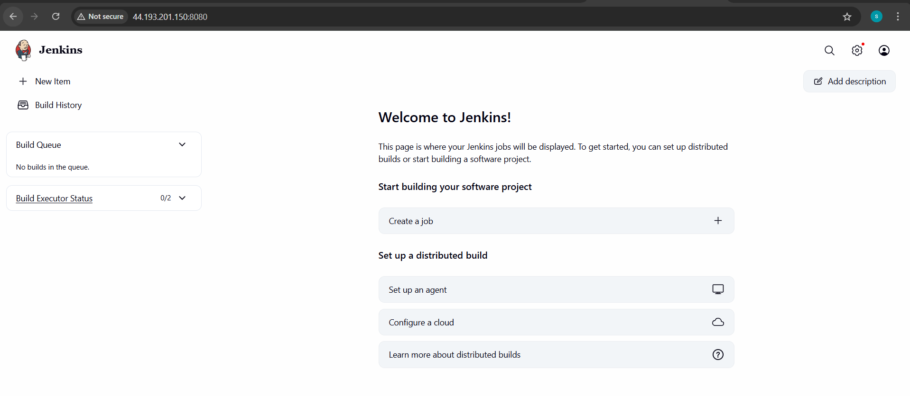
Step 7: Create a Sample Job
Click
**New Item**
1. Enter name: `sample-job`
2. Select: **Freestyle project**
3. Click OK

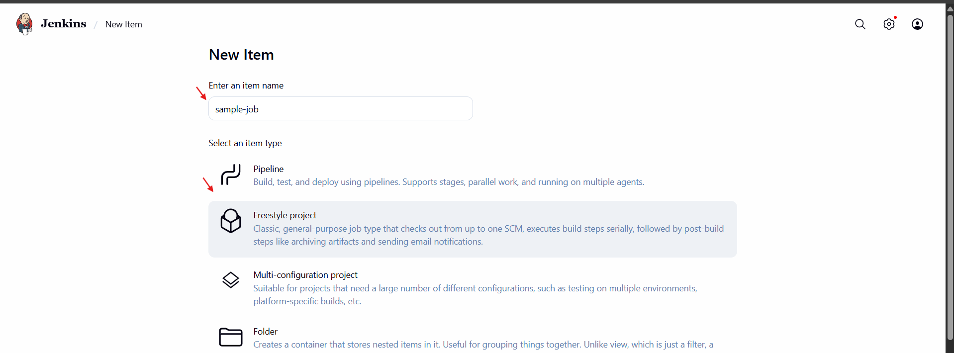
Add Simple Build Step
Scroll to:
**Build → Add build step → Execute shell**
Add:
```bash
echo "Hello from Jenkins!"
date
```
Click **Save**

Step 8: Run the Job
Click:
**Build Now**
Then click the build number → Console Output.
You’ll see:
```
Hello from Jenkins!
Fri Feb 27 2026
```
Jenkins job successful!

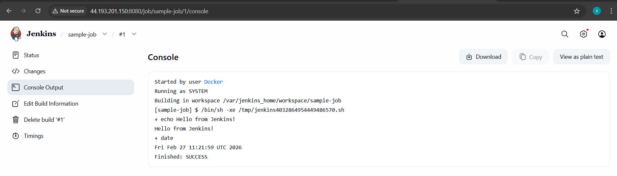
Stop / Remove Jenkins (optional)
Stop:
```bash
docker stop jenkins
```
Remove:
```bash
docker rm jenkins
```
